Write a Python program to calculate the area of a rectangle given its length and WIDTH flowchart
Formula:
START
Area of rectangle = length *breadth
Input Format:
- First line contains a float value representing the length of the rectangle
- Second line contains a float value representing the width of the rectangle
Output Format:
Input length, width
- Print the area of the rectangle as a float value formatted to 2 decimal places.
code
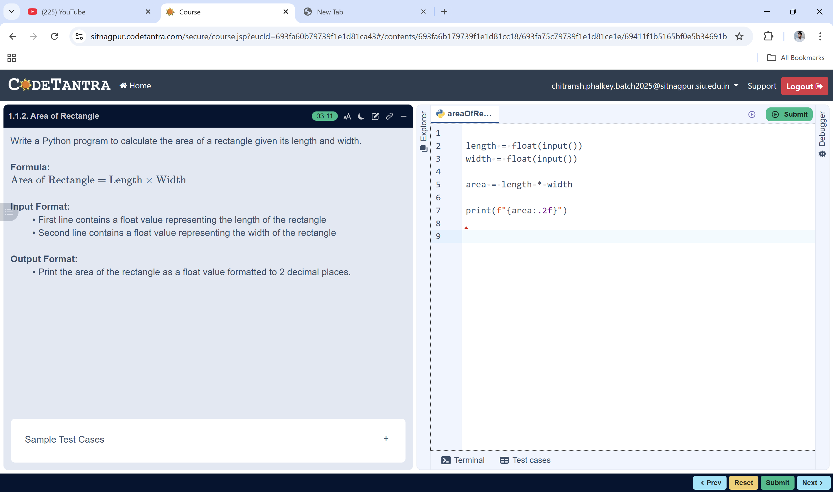
Print area (2 decimals
area = length × width

Algorithm: Area of a Rectangle
- Start
- Read the value of length from the user
- Read the value of width from the user
STOP
- Calculate the area using the formula:
area = length × width
- Display the value of area formatted to 2 decimal places
- Stop

